**ANIMAL QUIZ – COMPLETE TEMPLATE GAME**

**THANK YOU FOR PURCHASE MY GAME! ;)**

1. **INTRODUTION**
2. **Gameplay**

This is a quiz game, you will see 5 image of animals, 1 target and 4 opts, your mission very simple, just select the animal of the same species with the target animals.

1. **Feature**

+ 50 difference animals with sound

+ 2 Mode gameplay: Normal and KidMod (more time)

+ Easy to play

+ Easy to mod, reskin

1. **HOW TO SETUP**

Open the Play scene in Scene folder. You will see main UI

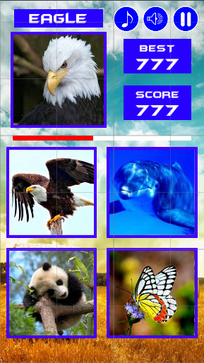

Timer

Target Animal

**In Hierachy**

1. 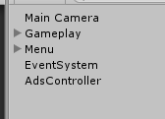**Menu**: Main Menu UI
2. **Gameplay**: manager all animals and gameplay
3. **AdsController**:manager admob ads
4. **Menu**

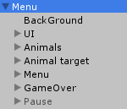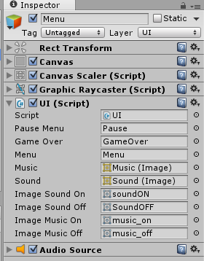UI script:place all objects in this, almost of them are in UI object in Menu object.

* **Animal UI**: 4 opts pick animals
* **Menu UI**: Show up when start game
* 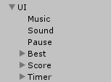**Both of them are controlled by Gameplay object**
* **Menu**: 2 mode

1. **Gameplay:** Control create animals and handle gameplay

* 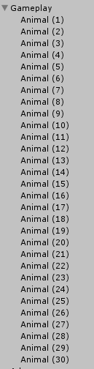I just create 30 animals, if you want more you can follow my instruction below, very simple

+ Create new object and place it into Gameplay object, Drag Animal script on it

* 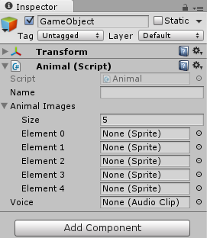**Name**: Name of new animals
* **Animal Images**: Fill number 5 and choose 5 image of one animals
* **Voice**: Search sound of that animal

+ That’s it! Easy right?

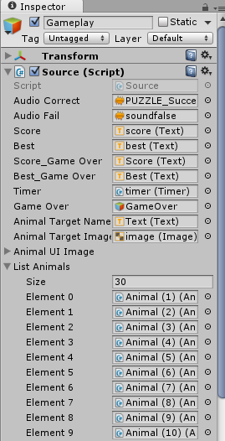Look at Source script of Gameplay object, you need to place it fully with UI object in Menu

* **Score** and **Best** in UI
* **Score_Game Over** and **Best_Game Over** in GameOver object
* **Timer:** timer bar object script
* **GameOver:** gameover object
* **Animal Target Name, Animal Target Image and** List of **Animal UI Image** are in Menu object
* **List Animals:** place all animals in Gameplay in this List. Current 30 animals, if you want more, increase it by create new Animal like I said above and place it in this List Animals

1. **AdsController**

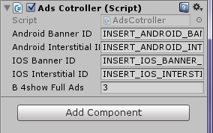Just copy your admob ID and paste on it, everything is ready.

**That’s all! If you have any question please contact me:** [**phanbanhut@gmail.com**](mailto:phanbanhut@gmail.com)

**Please review my game, it will help me a lot! ;)**